AP25794101 «STUDY OF TECHNOGENIC FACTOR AND CLIMATE CHANGE IMPACT ON TREE SPECIES IN INDUSTRIAL REGIONS OF EASTERN KAZAKHSTAN BY DENDROINDICATION METHOD»

The purpose of the project: to investigate the impact of technogenic factors and climate change on the viability, productivity, and regeneration of tree species in the industrial regions of Eastern Kazakhstan in order to ensure sustainable ecosystem management, their rational use, and the effective improvement of polluted environmental conditions in cities.
Amount of funding: 26 237,74895 thousand tenge

Priority area: Ecology, environment and rational use of natural resources

Relevance of research: Given the increasing anthropogenic pressures and global climate changes, it is essential to study in greater depth how these factors affect woody plants, which are an integral part of ecosystems and an important resource for society. The relevance of the study is justified by the threats of ecosystem degradation and biodiversity loss, as well as the need to develop practical recommendations for forest resource management.

Expected results:
- Publication of two research and/or review articles in peer-reviewed journals indexed in Scopus (CiteScore percentile ≥ 50).
- Publication of one research article in a national peer-reviewed journal recommended by KOKSNVO.
- Development and publication of a textbook/manual on dendrochronology in Kazakhstani publishing houses.
- Inclusion of the discipline “Dendrochronology” in the catalogue of elective courses of the educational programme 6B08301 “Forest Resources, Game Management and Beekeeping”.
- Development of educational content for the discipline “Dendrochronology”.
- Creation of an interactive dendro-map of industrial cities of Kazakhstan.
- Development and implementation of a dendroindication methodology for assessing the condition of woody plants and monitoring environmental quality.
- Conducting a series of scientific and methodological webinars on the resilience of woody plants and monitoring of urban ecosystems.
- Organization of an international scientific-practical conference on technogenic and climatic impacts on woody plants in industrial cities of Kazakhstan.
- Obtaining an author’s certificate for the interactive dendro-map and the dendroindication methodology.

Fields of application of developments: The project results can be used within the system of state environmental monitoring and environmental protection. They are applicable in the field of natural resource management and nature use, as well as in forestry and forest restoration activities. The obtained scientific data and developed digital tools may be applied in urban greening and landscaping of industrial cities.
The project materials will be in demand in research activities in the fields of ecology, biology and forest science, as well as in higher and postgraduate education. The developments can be used in environmental planning, environmental impact assessment and the development of environmental protection measures. In addition, the project results may be utilized by public and non-profit environmental organizations in the implementation of environmental programmes and initiatives.
The name of the competition within which the project is being implemented: Competition for grant funding of young scientists under the «Zhas Galym» project for 2025-2027

Photos or additional materials
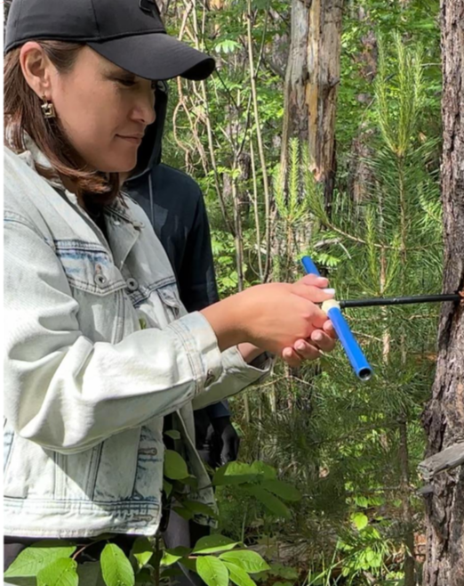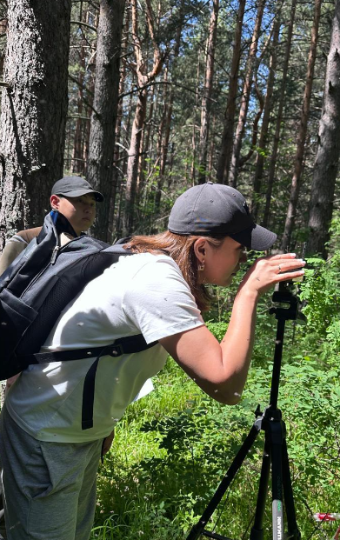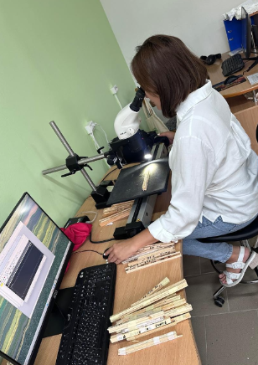
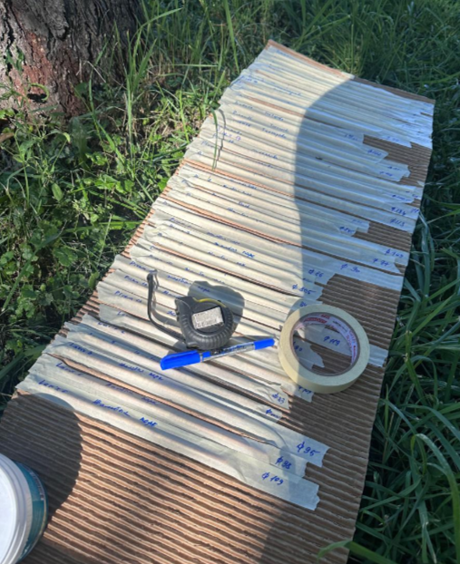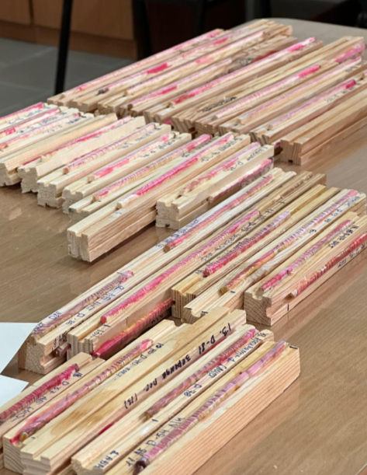

Publications:
Alipina, K. B., Abilova, Sh. B., Dulamsuren, Ch., & Tergenbayeva, Zh. T. (2025). Dendrochronological analysis of the response of tree species to climate change in high-mountain ecosystems of Eastern Kazakhstan. Bulletin of West Kazakhstan University. Oral, 2025. – Т. 99, № 3. – С. 148. – DOI: https://doi.org/10.37238/2960-1371.2960-138X.2025.99(3).148

The Research Group:
Scientific Supervisor of the Project – Alipina Kuralay Baurzhanovna, senior lecturer of the department of biology.
Scientific Consultant of the Project – Choimaa Dulamsuren, Doctor of biological sciences, professor at the Albert Ludwig University of Freiburg (Germany).

