АР26103871 «DEVELOPMENT OF SCIENTIFIC AND TECHNOLOGICAL FOUNDATIONS FOR OBTAINING COMPOSITE PROTECTIVE COATINGS USING INDUSTRIAL WASTE»

The purpose of the project: development of scientific and technological justification for using industrial waste as raw material for obtaining protective coatings.

Amount of funding: 120 million tenge

Priority area: energy, advanced materials and transportation

Relevance of research: The main idea of the project is to use industrial waste as raw material for obtaining protective coatings. Within the project, work will be carried out in three directions using gas thermal spraying methods for obtaining coatings: 1) Obtaining a biocomposite coating using silicon dioxide (SiO₂) derived from rice husk; 2) Obtaining a glass-ceramic coating using glass waste, silicon carbide (SiC) derived from rice husk, and potassium oxide (K₂O) derived from sunflower husk; 3) Obtaining protective coatings using fly ash generated from coal combustion in thermal boilers. Within the project, a methodology for obtaining composite materials from industrial waste will be developed, gas thermal spraying technologies for coating from composite materials will be refined, and the characteristics and properties of the resulting coating will be comprehensively studied.
This project not only addresses the environmental issue of utilizing industrial waste but also enhances the economic efficiency of obtaining protective coatings by using industrial waste as an inexpensive raw material source

Expected results:
- A methodology for obtaining silicon dioxide (SiO₂) from rice husk will be developed and comprehensively studied, including the determination of chemical and phase composition, particle size analysis, and investigation of thermal stability;
- A methodology for obtaining HA-SiO₂ (from rice husk)-ZrO₂ composite materials adapted for gas thermal spraying technology will be developed;
- A methodology for obtaining HA-SiO₂ (from rice husk)-ZrO₂ biocomposite coatings using detonation and air plasma spraying technologies will be developed, and the optimal technological parameters for coating application will be determined;
- The cytotoxicity, biostability, and mechanical-tribological properties of the HA-SiO₂ (from rice husk)-ZrO₂ biocomposite coating will be comprehensively studied;
- A methodology for obtaining potassium oxide (K₂O) from sunflower husk and silicon carbide (SiC) from rice husk will be developed, and the resulting K₂O and SiC powders will be comprehensively studied, including the determination of their chemical and phase composition, particle size analysis, and investigation of thermal stability;
- A methodology for obtaining a glass-ceramic material from SiC (from rice husk), K₂O (from sunflower husk), and glass waste will be developed based on the processes of remelting and mechanical pulverization;
- The optimal parameters for obtaining glass-ceramic coatings based on SiC (from rice husk), K₂O (from sunflower husk), and glass using detonation and air plasma spraying technologies will be determined;
- The hardness, wear resistance, and corrosion resistance of the glass-ceramic coating will be studied;
- The potential for obtaining coatings from fly ash using air plasma spraying technology will be investigated;
- The hardness, wear resistance, and corrosion resistance of the fly ash-based coating will be studied.

Fields of application of developments: energy, mechanical engineering and materials science, biomedicine.

The name of the competition within which the project is being implemented: competition for grant funding of scientific and (or) scientific and technological projects for 2025–2027

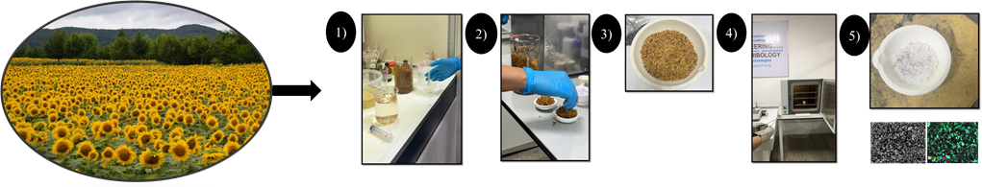

The Research Group:
Project Leader, Leading Researcher – Bektasova G.S.;
Senior Researcher – Sagdoldina Zh.B.;
Senior Researcher – Buitkenov D.B.;
Senior Researcher – Sulyubayeva L.G.;
Senior Researcher – Muhammad Norazlan Abd Aziz;
Senior Researcher – Nur Nabihah Yusof;
Senior Researcher – Baizhan D.R.;
Senior Researcher – Maulet M.;
Junior Researcher – Berdimuratov N.E.;
Engineer – Bolatov S.D.

