AP26103881 «DEVELOPMENT OF AN EFFECTIVE TECHNOLOGICAL PROCESS FOR OBTAINING PROTECTIVE COATINGS BASED ON SELF-FLUXING ALLOYS IN ORDER TO CREATE A COMPREHENSIVE SOLUTION AGAINST HIGH-TEMPERATURE CORROSION OF PARTS OF POWER ENGINEERING»

The purpose of the project: Development of an integrated technological process combining gas-thermal spraying and laser processing technologies to create high-performance protective coatings based on self-fluxing powders, providing resistance to high-temperature corrosion and wear in the conditions of power engineering industries.

Amount of funding: 150 millon tenge

Priority area: Energy, advanced materials and transport

Relevance of research: The project is aimed at developing an integrated technological process combining thermal spraying and laser processing methods to create highly effective protective coatings based on self-fluxing Ni-Cr-B-Si powders. These coatings provide high resistance to high-temperature corrosion and mechanical wear in power engineering, where materials are exposed to aggressive environments, including combustion products and gases. The relevance of this project is due to the growing challenges associated with high-temperature corrosion, which poses a serious threat to the reliability and durability of power plants. Periodic failures in power equipment can lead to significant economic losses and safety risks, so the need to develop innovative coatings that can effectively resist corrosion processes at high temperatures and loads remains an urgent task.

Expected results:
- the theoretical and methodological foundations of thermal spraying and determination of the optimal composition of self-fluxing powders providing protection against high-temperature corrosion using modeling methods will be studied;
- a method for producing self-fluxing coatings based on Ni-Cr-B-Si using flame spraying will be developed and the influence of process parameters (temperature, gas flow rate, pressure) on microstructural features (grain sizes and shapes, dispersion, structure defects), microhardness and adhesive properties will be studied;
- a method for producing self-fluxing coatings based on Ni-Cr-B-Si using the detonation spraying method will be developed, and an assessment will be made of the influence of technological factors (filling volume of the explosive mixture, molar ratio of gases, holding time between shots) on the microstructural characteristics (size and shape of grains, dispersion, structural defects), microhardness and adhesive properties of the coatings;
- an analysis will be made of the structural-phase state and basic surface characteristics of the coatings (roughness, porosity and wear resistance) obtained using the flame and detonation spraying methods;
- a modeling of the process of forming protective coatings will be performed with an emphasis on studying the interactions in the area of ​​contact "coating - substrate" using the combined method of thermal spraying followed by laser processing;
- the optimal parameters of laser processing (radiation density and power, beam canning speed), as well as the modes of gas-thermal spraying under conditions of combined use will be determined. The effect of laser processing on the mechanical properties and wear resistance of coatings created by the flame and detonation spraying method will be studied;
- high-temperature tribological tests will be carried out and wear mechanisms of coatings obtained by the combined method of gas-thermal spraying with subsequent laser surface treatment will be determined;
- the patterns of formation of protective coatings based on self-fluxing powders will be studied, with an emphasis on identifying the relationships between the structural-phase composition and adhesive properties;
- the operation processes of combined protective coatings on real parts will be simulated taking into account the thermophysical properties to identify critical parameters and mechanisms of surface destruction;
- tribocorrosion tests will be conducted in various aggressive environments (salts and sulfates), and the corrosion properties of self-fluxing coatings after laser treatment will be determined;
- parts will be processed using the developed combined method of gas-thermal spraying followed by laser treatment. The corrosion resistance and erosion resistance of steel products with protective coatings at high temperatures in aggressive environments will be studied on special stands.
- based on the results of all the studies, practical recommendations will be formulated for the implementation of combined technologies in production processes.

Fields of application of developments: energy, mechanical engineering, and the oil and gas industry.

The name of the competition within which the project is being implemented: Competition for grant funding of scientific and (or) scientific and technological projects for 2025–2027

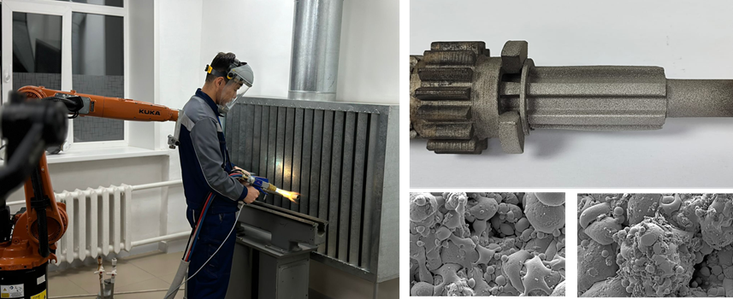
The Research Group:
Project Leader, Leading Researcher – Kylyshkanov M.K.;
Leading Researcher – Sulyubayeva L.G.;
Leading Researcher – Buitkenov D.B.;
Senior Researcher – Leszek Latka;
Senior Researcher – Maulet M.;
Junior Researcher – Kambarov E.E.;
Junior Researcher – Berdimuratov N.E.;
Junior Researcher – Nabioldina A.B.;
Junior Researcher – Raisov N.S.;
Engineer – Alibekova B.A.

